How to purchase a booth/sponsorship

- Go to TOI website at www.toi.org, scroll down on the main page and review all TOI Conference sponsor, exhibit, advertising options. Choose the option to purchase and click “claim” button that corresponds with the option you are purchasing.

- After clicking on the “claim” button, it will take you to another screen that requests the company name and contact person making the purchase.

- In the first box type in the name of the company, if the company is not currently in the TOI database the system will show . If this occurs, click on the green box to the right, and type in the company name, address, city, state, zip code and click at the bottom of the screen.

- After the company is displayed in the first box, complete the second box with the contact information of the individual who is completing the purchase. If this individual is not already registered as a company representative in the TOI database, the system will show . If this happens click on the green box to the right, and type in first and last name, organization (your company), address, city, state, zip code, email and click at the bottom of the screen.

- After the company name is in the first box and the name of the individual making the purchase is in the second box, click on the bottom right of the screen.

- The next screen is a review of your purchase. To include: item (s) you are purchasing the quantity, individual item price and total amount. After review of the purchase, click at the bottom right of the screen. If changes are needed of the purchase,

- The final screen is the confirmation/payment screen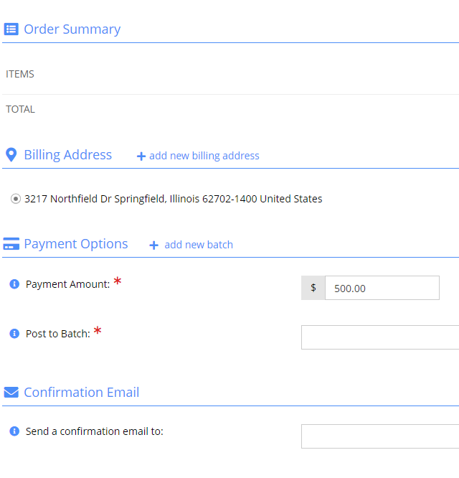

*Please note if a billing address is not entered you will not be able to proceed*

- To enter or edit the address on this screen, click

- After the address has been entered click on the arrow in the box next to “post to batch” and click on the top date.

- Once clicked, the payment section will appear, and choose a payment option. To request an invoice, select the Bill Me. This will generate an invoice that will be automatically emailed to the individual making the purchase. If you pay by credit card an invoice will be emailed to the individual making the purchase.

- Finally, enter the email you wish to have the invoice/confirmation to be emailed. Once you have the email entered click on . After you have submitted your order you will receive the email and you have been registered for a booth/sponsorship.

