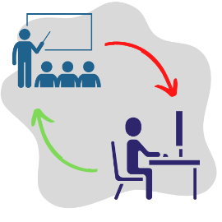
2023 Hybrid Learning Events
The TOI Education Program is pleased to offer several Hybrid Learning Events for Township Officials and Staff. These Hybrid Learning Events will blend in-person instruction at the TOI Office with the ability to participate virtually via Zoom from the comfort of home. They will focus on a singular topic over an afternoon with the ability to ask questions of a Township Attorney.
The in-person session capacity is limited to 25 attendees; the cost is $25. The online session capacity is unlimited; the cost is $15. The seminars are scheduled from 1pm to 4 pm to accommodate travel time.

All online registrants will receive the login link prior to the scheduled event.

Please fill in all information below and print clearly.
April 18 – Bettering Your Road District
Tim Peters and Barry Kent, IDOT
Join us at the TOI Office or through Zoom to learn more about Motor Fuel Tax (MFT), uses of MFT funds, and Ethics in the Road District.

q $25 In-Person Course | q $15 Online Course

Name: ______________________________________________________________________________
Township Position: _____________________________________________________________________________________ County/Township: _____________________________________________________________________________________
Address: _____________________________________________________________________________________ City, State, Zip: ____________________________________________________________________________________ Phone/Email: _____________________________________________________________________________________
Registration is $25/person OR $15/person, depending on course type. Refunds cannot be given for any cancellations received after the deadline to register.
Payment method: Check or Credit Card. Please make checks payable to Township Officials of Illinois.
Credit Card (Visa / MasterCard only) Card Number: _____________________________________________________________ Exp: __________________
Signature: __________________________________________________
Return to the TOI office by fax at 217.744.7419, email to kayla@toi.org, or mail to 3217 Northfield Dr., Springfield, IL 62702.

