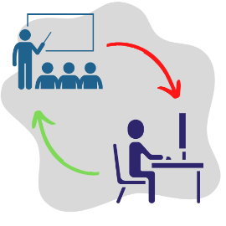
2022 Hybrid Learning Events
The TOI Education Program is pleased to offer several Hybrid Learning Events for Township Officials and Staff. These Hybrid Learning Events will blend in-person instruction with the ability to participate virtually via Zoom from the comfort of home. They will focus on a singular topic over an afternoon with the ability to ask questions of a Township Attorney.
The in-person session capacity is limited to 25 attendees; the cost is $25. The online session capacity is unlimited; the cost is $15. The seminars are scheduled from 1pm to 4 pm to accommodate travel time.

All online registrants will receive the login link prior to the scheduled event.

Please fill in all information below and print clearly.
January 18 - Employee Handbook on Township Government and Preparing for the Upcoming Year
q $25 In-Person Course | q $15 Online Course
February 17- Decennial Committee on Local Government Consolidation and Efficiency Act.
q $25 In-Person Course | q $15 Online Course

Name: ______________________________________________________________________________
Township Position: _____________________________________________________________________________________ County/Township: _____________________________________________________________________________________
Address: _____________________________________________________________________________________ City, State, Zip: ____________________________________________________________________________________ Phone/Email: _____________________________________________________________________________________
Registration is $25/person OR $15/person, depending on course type. Refunds cannot be given for any cancellations received after the deadline to register.
Payment method: Check or Credit Card. Please make checks payable to Township Officials of Illinois.
Credit Card (Visa / MasterCard only) Card Number: _____________________________________________________________ Exp: __________________
Signature: __________________________________________________
Return to the TOI office by fax at 217.744.7419, email to kayla@toi.org, or mail to 3217 Northfield Dr., Springfield, IL 62702.

