We preserve the history of our Township as it happens.
February 2023
What your dues paid for in 2022…
• Preparation work and handouts for education sessions
• Sponsorship of online education
• Sponsorship of the T.O.I. Annual Conference
• William Z. Ahrends Award
• VTCC materials
• T.O.I. Scholarships
Dear Township Clerk:
It is time to renew your 2023 Membership Dues for the Township Clerks of Illinois. Your township should pay your annual dues from Township funds, as Township Clerks are a division of Township Officials of Illinois.
Your membership will help you stay current on topics and issues we deal with as township clerks. The “Clerks Corner” is in every issue of the Township Perspective magazine. “Like” us on Facebook at Clerks Division of Township Officials of Illinois. Visit us at TOI.org website, as well.
$30
The Clerks Handbook is available in both printed version with a complementary jump drive (that includes all of the forms in Word format) and on the jump drive version alone, which includes a complete PDF of the handbook and all of the forms. An order form is available in every Township Perspective magazine. This is a “must have” for every clerk and is a tool your township should invest in for you.
Our Clerk Board of Directors is committed to being your source for education and information to help make your position as township clerk both rewarding and easy. If you have questions, please contact me at kdolanbaumer@hanover-township.org.

Please make check payable to Township Clerks of Illinois, in the amount of $30. Mark your check with 2023 T.O.I. Clerks Dues on the comment line, and mail along with this form to:  *If you pay by electronic bill pay, please email your updated information to: clerk@cordovatownship.com | Clerk Pam Bruner  Membership Coordinator  Township Clerks of Illinois  PO Box 311  Cordova, IL 61242
Regards,
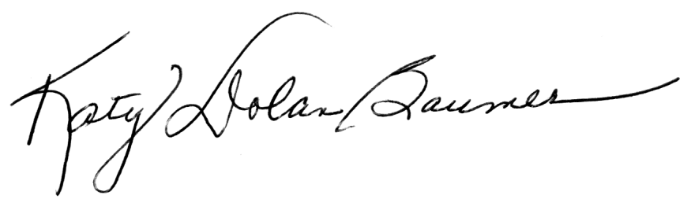
Katy Dolan-Baumer, President,
T.O.I. Clerks Division

------------------------------------------------------------------------------------------------------------------

Name:

County:
Township:

Address:

City/State/Zip:

Office Phone Number: Home Phone Number:

Cell Phone Number: Work Phone Number:

Fax Number: E-Mail Address:

We preserve the history of our Township as it happens.

Voluntary Township Clerk Certificate (VTCC) Program

The goals set forth by the Township Clerks of Illinois (TCI), an incorporated not for profit association, is to provide educational opportunities with training for Township Clerks by conducting educational conferences in geographical locations and to promote legislation beneficial to the operation of Township Government.

In line with our goals, the Board of TCI has developed the Voluntary Township Clerk Certificate (VTCC) program, designed to enhance the job performance of the Clerk in Illinois Townships. To earn the VTCC designation, a township Clerk must attend education programs, requires experience as a township Clerk, and demonstration of commitment to community service. The VTCC program prepares the applicants to meet the challenges of the complex role of Township Clerk.

To achieve our goal of conducting educational conferences in geographical locations across the state and to promote legislation beneficial to the operation of Township Government we partnered with the Township Officials of Illinois. This partnership contributes to the success of the quality of education programs that are offered.

For more information about this program, please keep an eye on the Perspective magazine, check out the webpage on TOI.org, the Clerks Division of Township Officials of Illinois (where the forms may be downloaded) or contact one of the VTCC Coordinators: Jewel Ward, Linda Eades, or Kathy Brown.

TOI Clerks Mission Statement: Unifying clerks across Illinois with a solid base in knowledge by providing quality education to better serve our constituency.

PLEASE NOTE: The dues MAILING ADDRESS

Clerk Pam Bruner
Membership Coordinator
Township Clerks of Illinois
PO Box 311
Cordova, IL 61242

Deadline for 2023 Dues:
Please submit your dues no later than September 22, 2023.
Thank you for your consideration.

